## I started my working life in one of the motherships of beautifully crafted advertising; Ogilvy. A pivotal time working in the mecca of advertising founded by the legend; David Ogilvy. My next adventure took me to the Middle East where I managed a regional piece of FMCG business. Moving back to the UK, I explored the world of pharmaceutical marketing, working on global healthcare brands, both Rx and consumer healthcare. Latterly, I have been involved in large scale digital transformation initiatives in the pharmaceutical space creating a centralised digital ecosystem for HCP/patient content. I have a passion for building brands and making clients’ brands successful.

**CHRONOLOGY**

Clients: Medidata, Stada, Zimmer Biomet  
Brought in to lead active workstreams across 3 clients. Strategy and creative being the heartland of woolley pau; I was instrumental in delivering omnichannel campaigns with outstanding creativity. We produced a beautiful piece of animation executed as a 60” film, digital ads, social media, and internal comms. Involved in the creation of a launch campaign for a biosimilar ophthalmology product for Stada. Helped to shape a set of brand guidelines for the EMEA region leveraging the global brand positioning and personality for Zimmer Biomet.

Spearheading digital transformation for a mid-sized pharmaceutical organization; Kyowa Kirin International. Involved in shaping a digital ecosystem across the business deploying a global HCP portal housing KKI’s brands across their top EU countries. Implementing a central CMS integrating it with Veeva ensuring digital is driving all aspects of the business. Building and evolving a CMS platform to deliver modularised content that can be leveraged for all KKI’s therapy areas/brands across all digital channels.

Senior Account Handler, October 2019 – June 2020 (freelance) 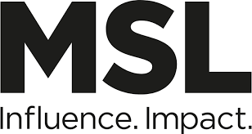

Client: P&G

Worked in the PGOne team (global inter-agency team for P&G); brought on board to work in the SciComms team to support on several briefs. Created, produced a European HCP credentialing toolkit for the Pampers brand; aim was to provide a strategic framework and guidance on effectively connecting with an HCP audience and building brand credentials through engaging with professional influencers.

Brand Consultant, August 2018 - Sept 2019 (freelance)    
Clients: Stryker, Distell Int’l, Bandai Namco  
Brought into agency to handle a large piece of HCP research for the launch of an ENT medical device for Stryker. Sourced research agency and delivered insightful findings which led to the development of a new brand positioning and a multi-channel comms plan. Integral to the production of an integrated campaign for a whisky brand; Black Bottle comprising of KLVs, display banners, social content, on/off trade assets and an updated Brand book. Played a new business role on Bandai Namco who market a brand called Funscape; a large entertainment centre across the UK. Single-handedly grew the business by 80%, built a relationship so within 6 months, we were receiving 90% of creative briefs.

Senior Account Director, June 2017 – March 2018 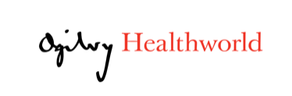   
Client: Intercept, Bayer Women’s Health, Clasado BioSciences  
Worked on a rare liver disease, PBC, for Intercept Pharma, managing their HCP and patient digital/offline comms. Campaign consisted of edetails, eleave behinds, digital display banners, email marketing, a patient education pack and brand presence at key liver congresses.

Was involved in the Bayer Women’s Health portfolio working across three oral contraceptive brands. Supported Bayer reposition two of their flagship brands creating innovative digital and social campaigns. Also worked on a small BioTech company; Clasado, handling the launch of a prebiotic powder, Bimuno, developing a campaign consisting of OOH, print, digital, social.

Senior Account Director, Feb – May 2017 (freelance) 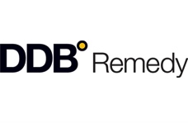

Client: Gilead   
Brought into the agency to lead a pitch for a TVC brief to create a disease awareness campaign for Hepatitis C. We won the brief, and I was asked to stay to drive forward the creative development process through to end delivery of an a-t-l campaign. Was integral to evolving and selling in the winning pitch concept from script, storyboard, shoot, post production and final delivery. Campaign idea translated into a 360 campaign; digital advertising, content, social, print, TV.  
  
Global Account Director, EMEA, August 2016 – Jan 2017 (freelance) Oliver

Client: Novartis

Lead and drove a team to create and deliver compelling, successful digital and social media content for two Novartis’ patient awareness campaigns; heart failure patient awareness concept; Keep It Pumping and an ophthalmology site; Set Your Sights. Worked within a highly regulatory environment producing social content that engages, resonates with our audience driving users to relevant online content and ultimately changing behaviour.

Regional Account Director, EMEA; March 2014 - July 2016   
Clients: Symantec, Veritas

Set up the Godfrey Q London office handling a Global Tech client; Symantec. Created and launched Symantec’ first global ad campaign across 22 geos; putting Symantec brand back in the Information Security space. Produced and rolled out a multi-media campaign, primarily digital (video content & display advertising), eDM, social and print - $2m media spend delivering 497m impressions, 22k leads generated, $19m pipeline business. In 2015 Symantec sold their Information Management portfolio and Godfrey Q won the Global account. Launched a digital creative campaign with a media spend in of $10m across US, China, Australia, UK, Germany. Positive results post launch; total media impressions 11m, video impressions 4.5m, total clicks 57k with a 0.6% CTR.

Senior Account Director; September 2013 – Februrary 2014 (freelance) 

Client: Sky Broadcasting

Headed up the Sky Winback and Retention accounts responsible for a £1.2m piece of retained business. Drove the Winback account strategically creating customer segments which targeted/tailored DM was delivered to.   
Senior Account Director; May – August 2013 (freelance) 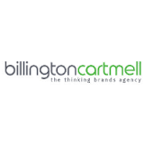  
Client: JTI

Worked in the Global Brand team across the JTI flagship brands; B&H, Silk Cut helping to create, produce and execute brand toolkits and guidelines providing creative direction and assets for local geos to leverage. Involved in producing product demo videos to merchandise new product development/product innovations across JTI’s RYO MYO (roll your own, make your own) brands including Camel, Old Holborn, Amber Leaf.

Senior Account Director; April 2012 – April 2013 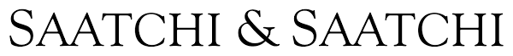  
Client: Heathrow Express  
Brought on board to manage and drive the Heathrow Express brand re-launch in mid 2012. Integral in the development of a new brand positioning and proposition, which was launched internally within the organisation and externally with a t-l-l advertising campaign. Responsible for the production of a £1m airport estate campaign across LHR and European airports. Transformed the account from a project based account to a £500k retained agency billings per annum.  
Global Programme Director; May 2010 – Feb 2012  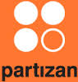Client: Reckitt Benckiser

An integral member of a start-up CRM/Digital agency specialising in developing/executing patient compliance/adherence programmes for Pharma & Consumer Healthcare companies. Involved in programme strategy and design, creative development, medical writing, graphic & web design for the E45 brand. Managed all print and mail house production. Closely involved in the implementation of each programme; web-based, call centre, sms, DM.      
Senior Account Director; Oct 2008 – April 2010(freelance)  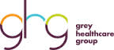Clients: Johnson & Johnson, Novo Nordisk

Headed up the Johnson & Johnson’s account; Neutrogena, building and driving a HCP /Pharmacy/ Consumer strategy through to execution of a creative campaign (consumer/trade press, pharmacy & GP sales brochures, branded materials for conferences; conference stand design, pop ups/nomadic stands, conference brochures.   
Account Director; Jan 2007 – September 2008 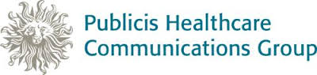  
Clients: Reckitt Benckiser, Sanofi Aventis

Managed both OTC and ethical brands globally and locally**.** Led and won many new business pitches for the agency; Danone, Ciba Vision. Headed up the OTC division managing the Reckitt Benckiser healthcare portfolio – Nurofen, Strepsils, E45 brands**.** Worked on various categories for Sanofi Aventis covering a wide spectrum of therapy areas; hypertension, anti-infectives, CNS, antihistamines.  
Regional Account Director; Nov 2002 – Dec 2006   
Client: Nestle Infant Nutrition

Headed upthe Regional Nestlé Infant and Adult Nutrition team across 13 geos in the Middle East.

Responsible for the brand leader in the Infant Nutrition sector. Developed and executed a holistic communication strategy and through-the-line campaign including new product launch ads.  
Account Executive - Account Director; 1997 – 2002 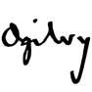

Clients: Unilever, American Express, British Tourist Authority, GlaxoSmithkline

Started my career at the Ogilvy & Mather where I cut my teeth in to the advertising industry. Starting out as an Account Coordinator on the Unilever and American Express accounts playing a Global coordination role where I became the knowledge bank for the brand. I quickly demonstrated my passion for creativity and got the opportunity and worked through the Account Management ladder to an AD working across FMCG sectors and OTC brands.

MSc – International Marketing; Strathclyde University, Glasgow  
Silver Medallist Ice Dancer  
References available on request